ENGR421 – HW1 REPORT

BERK BAHADIR BAHCETEPE

0071533

For this homework, I started with the data generation as wanted in the homework guideline. I created the class means, covariances and sizes and later generated each point using the parameters. I generated 3 different class and colored them to red, green and blue respectively. After, I labeled them with 1,2 and 3 respectively in order to distinguish them better while coding.

Later, I had to calculate the parameters which are going to be used while calculating the gscore of each class. These parameters are sample mean, covariance and class prior of each class. I calculated them with the formulas we derived in (Fig.1) and with the help of the previous labs.

Later, since this homework had 3 different classes, the gscore function was a quadratic function (Fig.2) with parameters Wc, wc and wc0 which I calculated using the formulas we derived in the lecture (Fig.3). with these calculated parameters I calculated the gscore of each class and stored them in a list. Later, in order to determine the predictions, I found the highest gscore value for each data point. In other words, I compared the gscore function of each data point for each class and grabbed the highest one’s index and added 1 to it. The reason of the latest addition is that the index range of the classes is between 0 and 2. But in order to match those indexs with their y label of which the range is between 1 and 3, we had to add 1 at the end.

I printed the confusion matrix with the help of Lab 3 and determined the x1 and x2 intervals and x1 and x2 grid using meshgrid function. In order to determine the discriminant values of each class, I used the equation in Fig.4. After, I got rid of the parts where each class’s is less the others.

In the end, I plotted the boundaries of each class and detected the miss predicted ones.

To conclude, I started doing this homework before the latest lecture in which we derived the softmax function. Therefore, I was not aware of the existence of that function, so I tried to make the prediction by calculating the gscore function. Since this gscore function was quadratic and the data was bivariate, the calculation of the function, thus the discriminant values, was hard. But eventually, I am glad to make the math and calculate it.

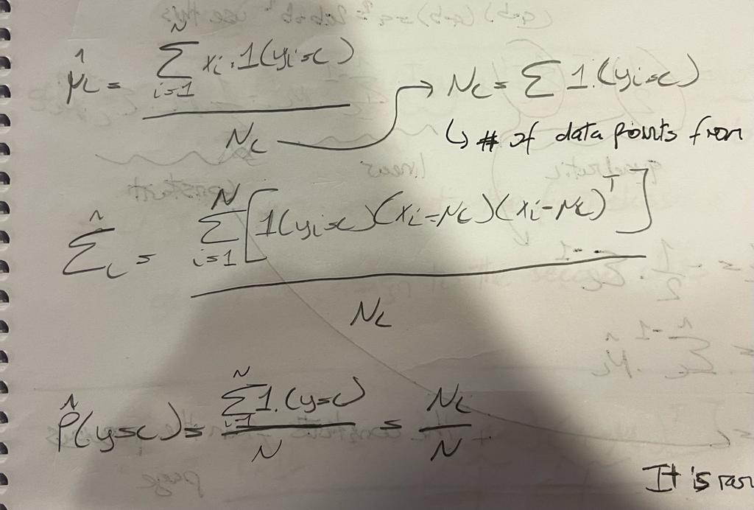

*Fig.1. The equations for sample means, covariance and prior probability*



*Fig.2. The quadratic g score funtion*

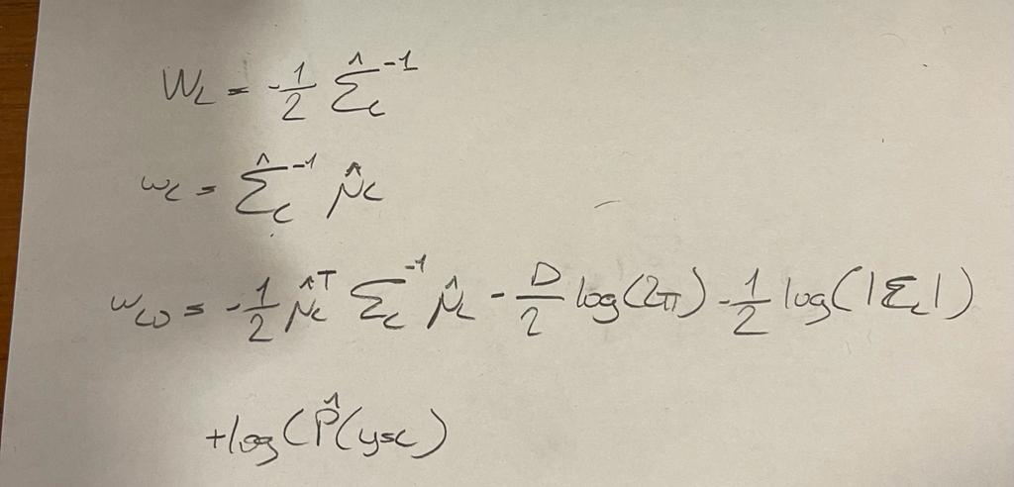

*Fig.3. The equations I used for calculating the parameters for the g score function*

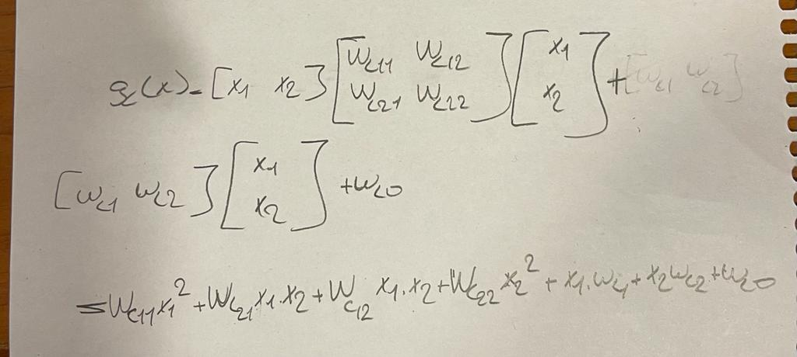

*Fig.4. The equation I used to calculate the discriminant values each class*